Interactive question of Sequences
https://stemcollection.com/r/12019

Preview

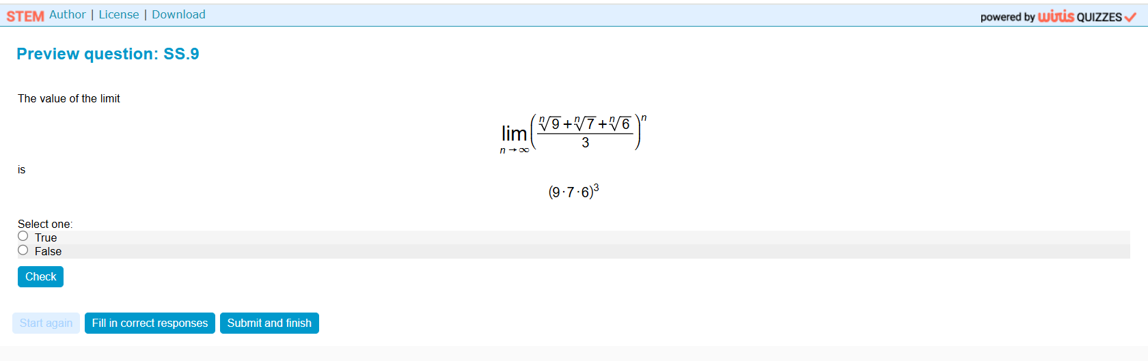

This question is part of the questions at STEM collection | WIRIS math

https://stemcollection.com/om/24/en

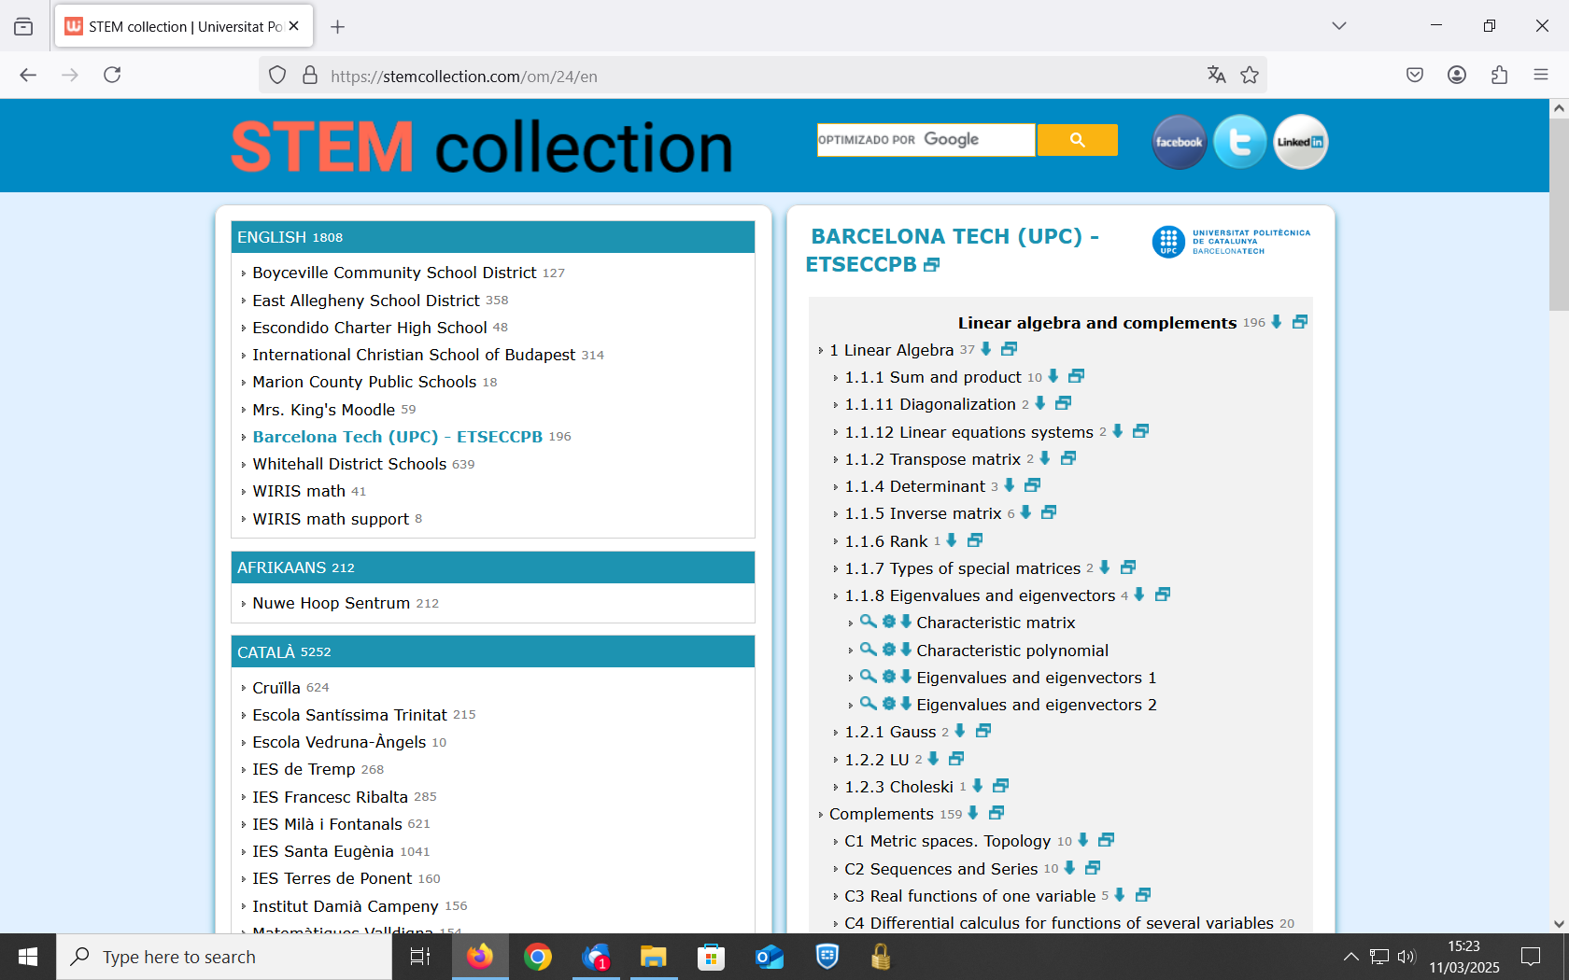

See that you can have the Algorithm of the question

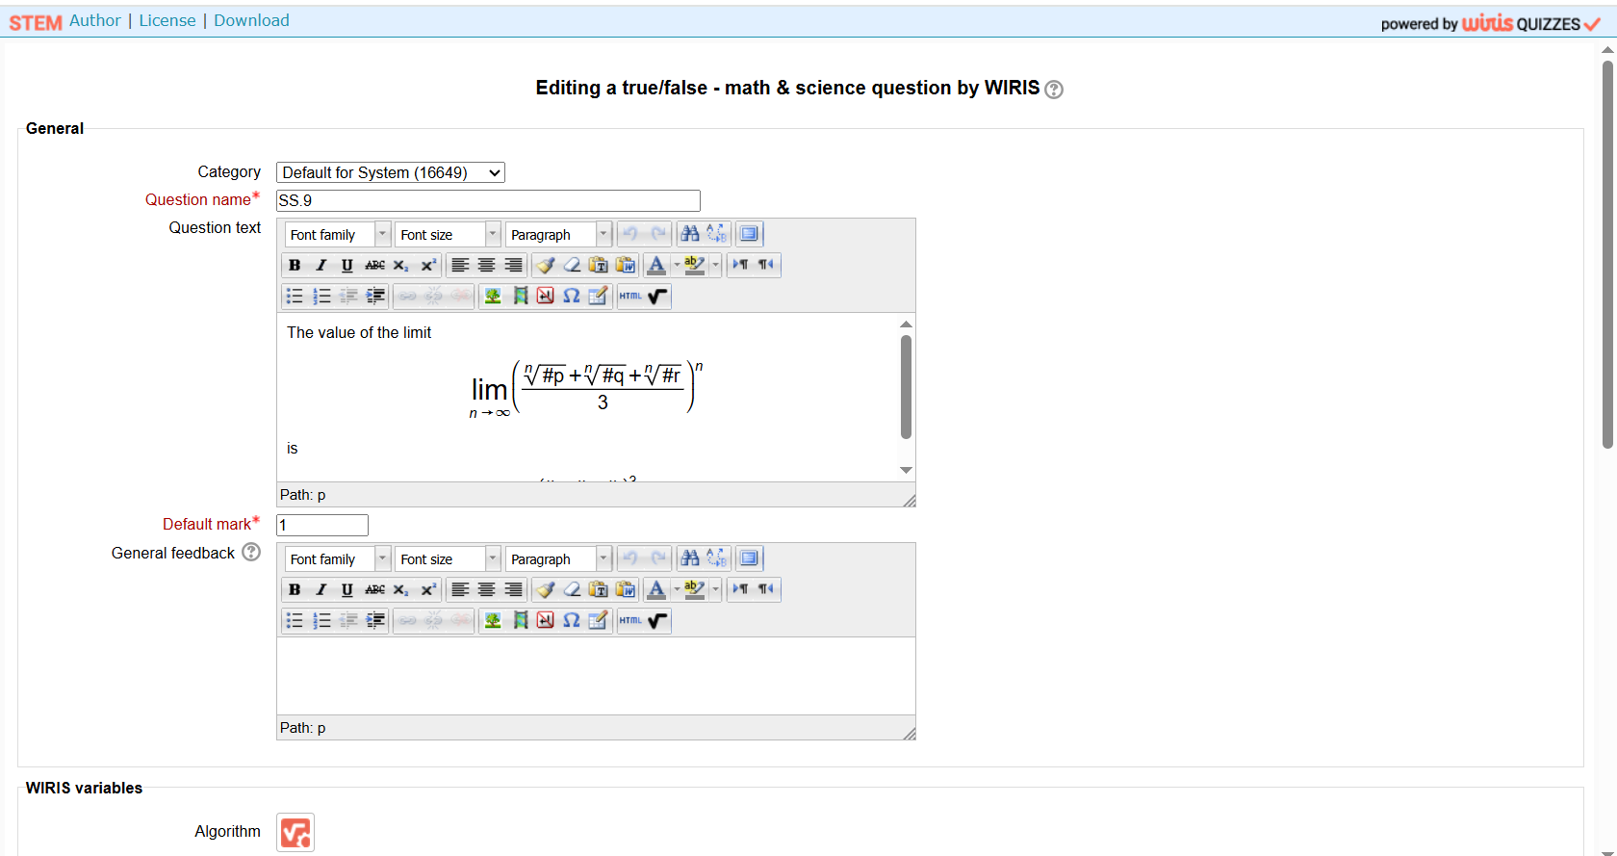
and also Download

