Interactive question of Choleski descomposition of a Matrix
https://stemcollection.com/r/12000

Preview
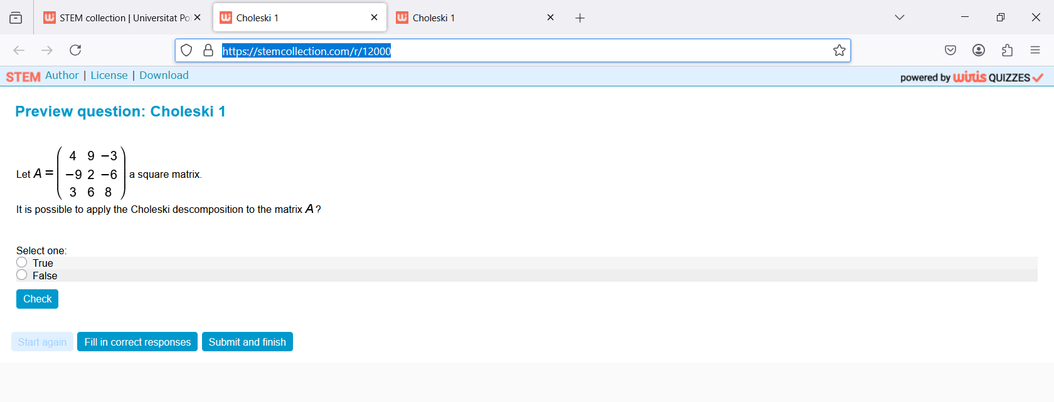
This question is part of the questions at STEM collection | WIRIS math

https://stemcollection.com/om/24/en

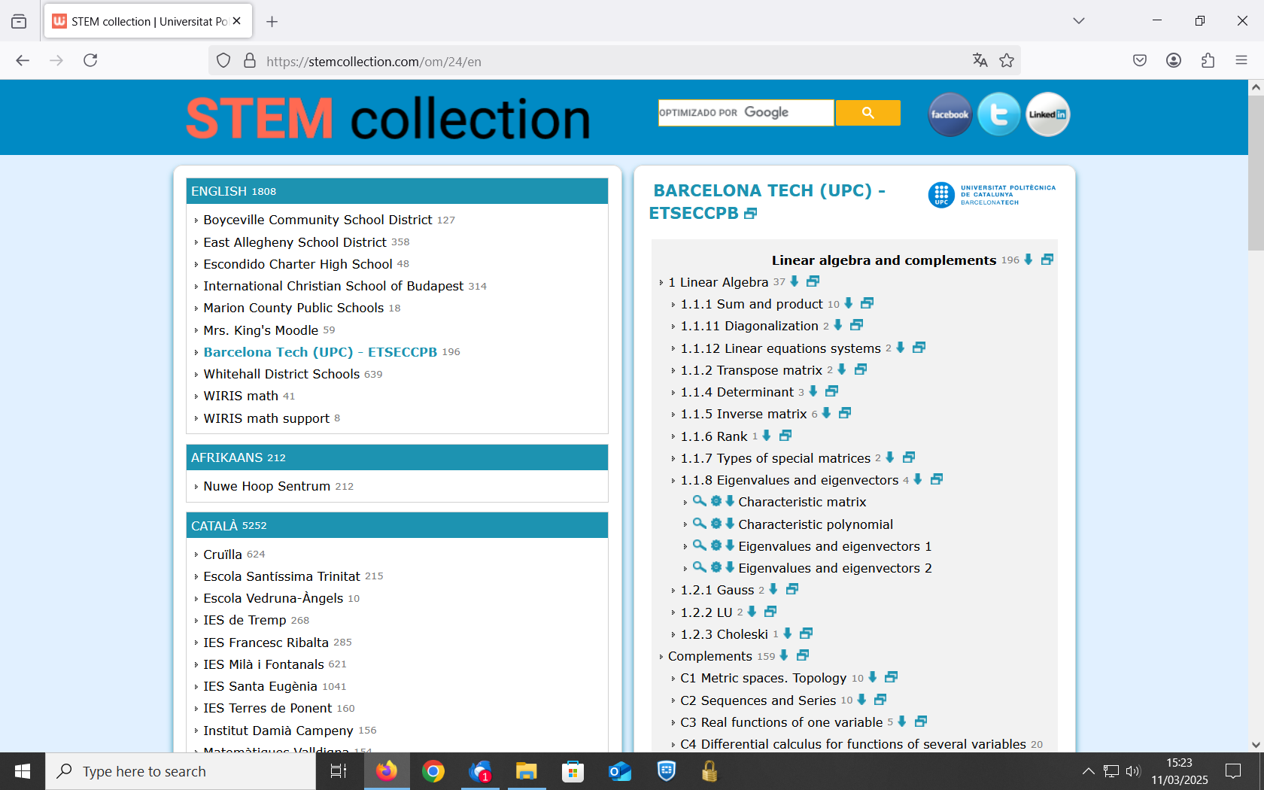

See that you can have the Algorithm of the question

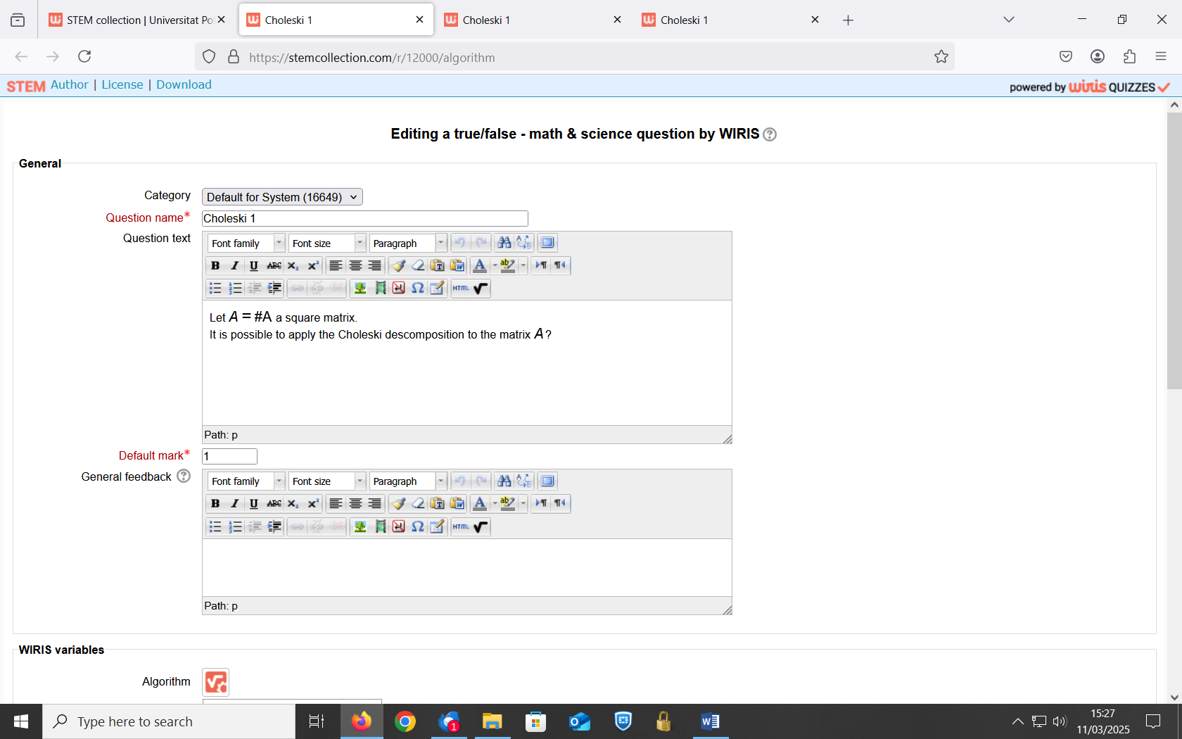
and also Download
