Interactive question of Particular Matrices
https://stemcollection.com/r/11990
Preview
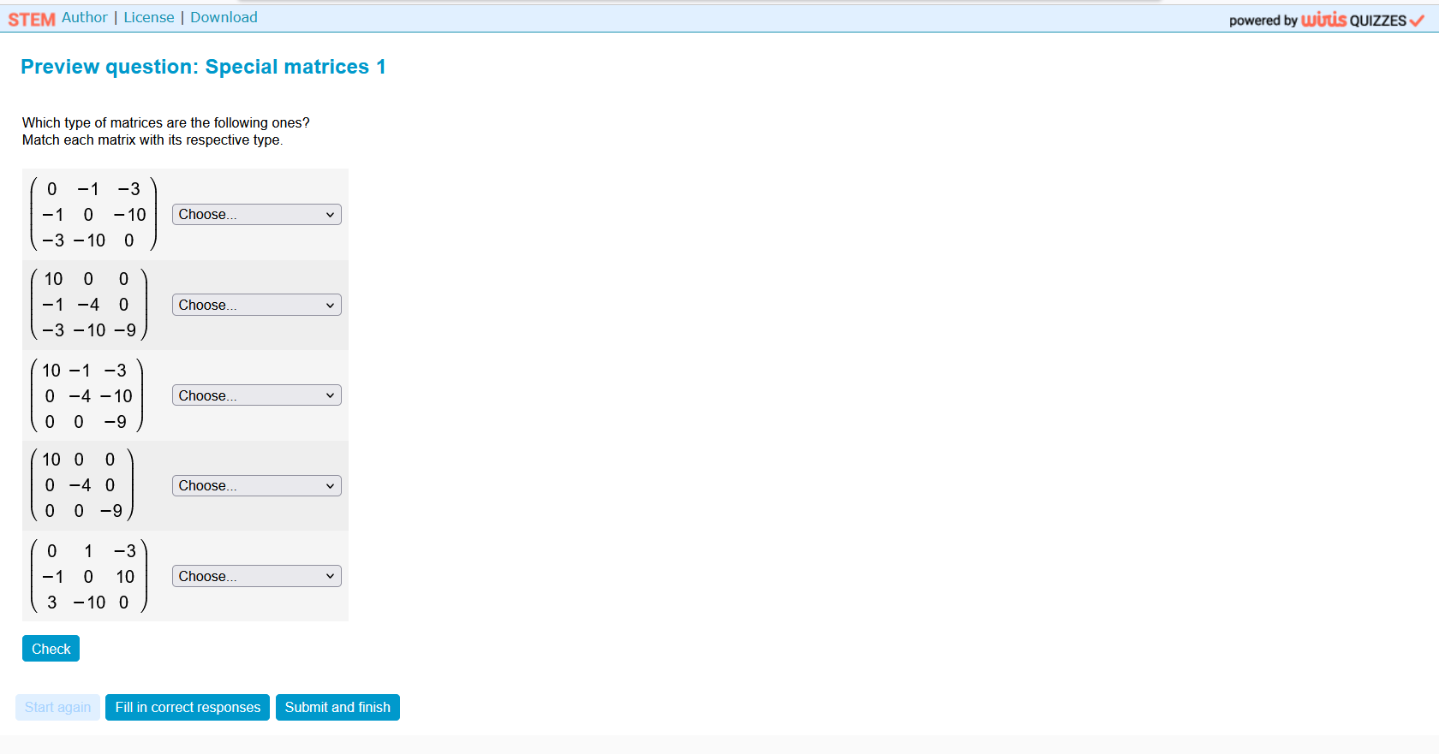

This question is part of the questions at STEM collection | WIRIS math
https://stemcollection.com/om/24/en

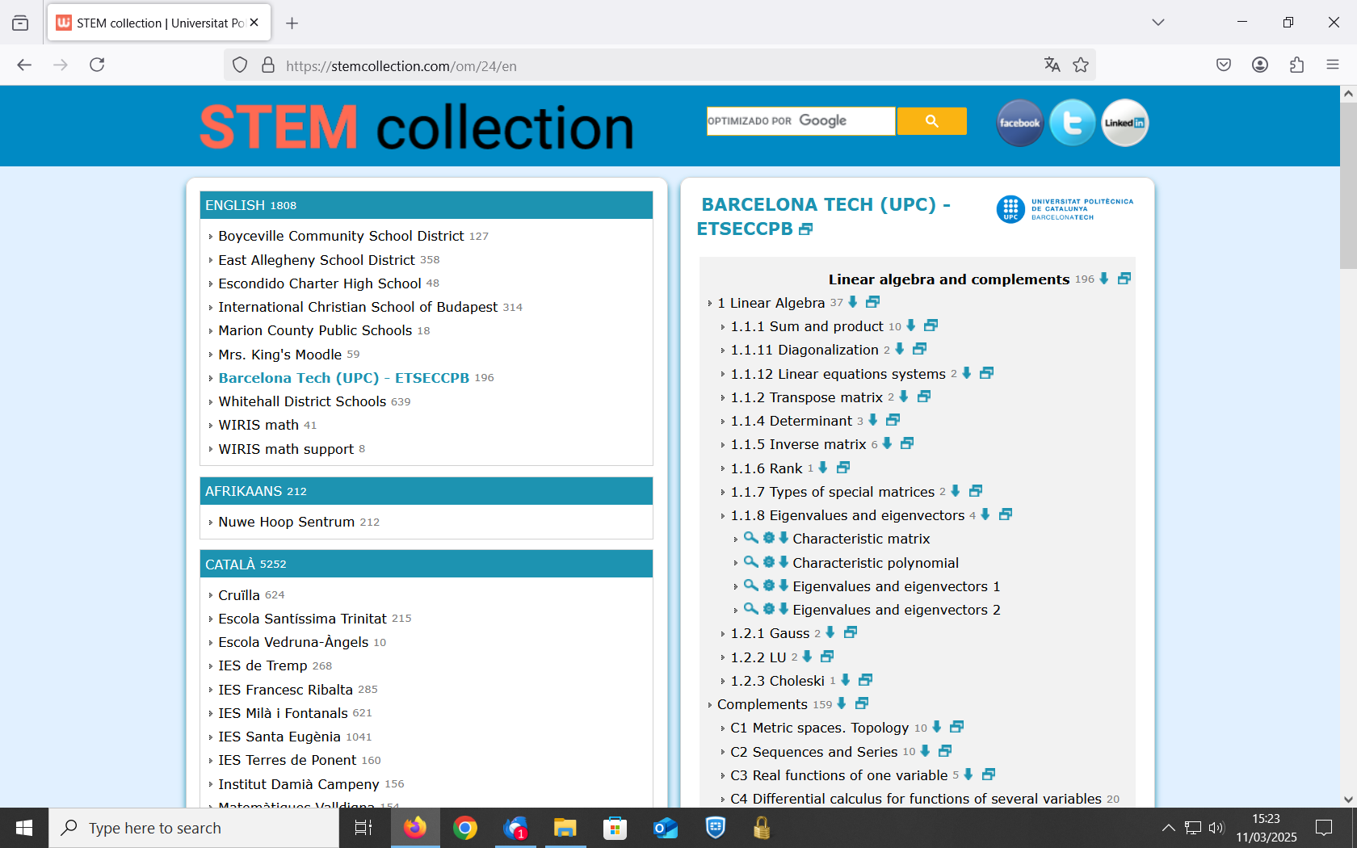

See that you can have the Algorithm of the question

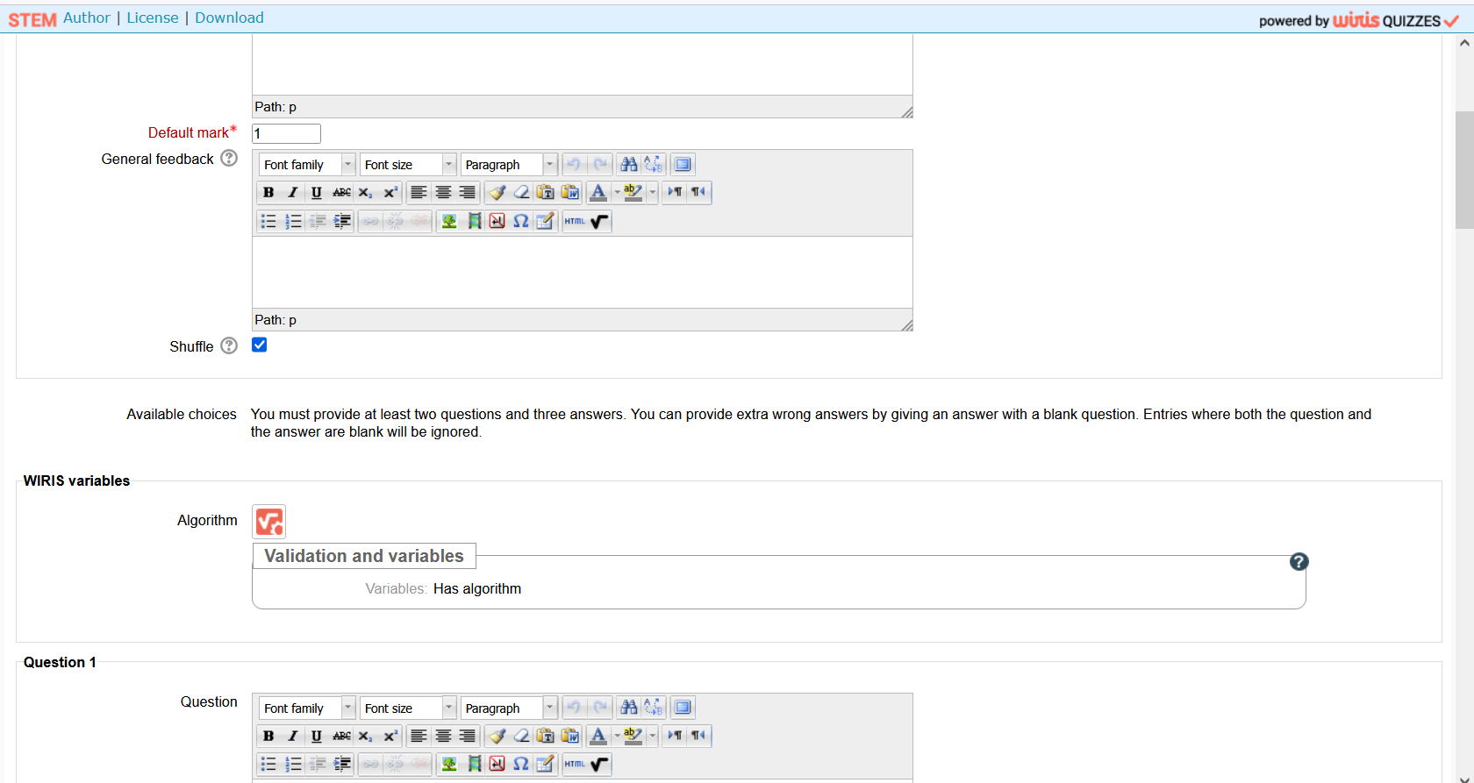

and also Download

