Interactive question of calculate a Jacobian Matrix
https://stemcollection.com/r/12026

Preview
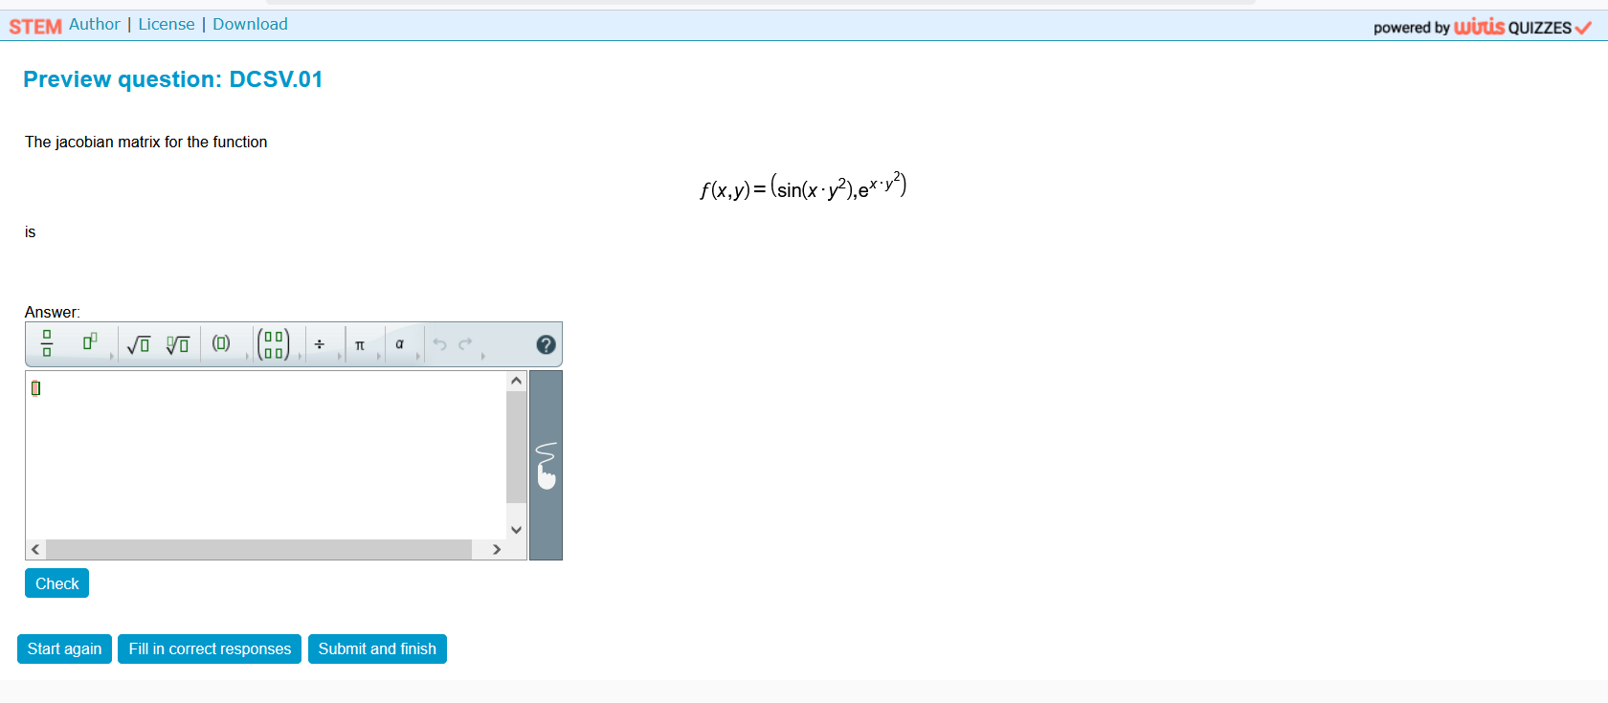

This question is part of the questions at STEM collection | WIRIS math

https://stemcollection.com/om/24/en

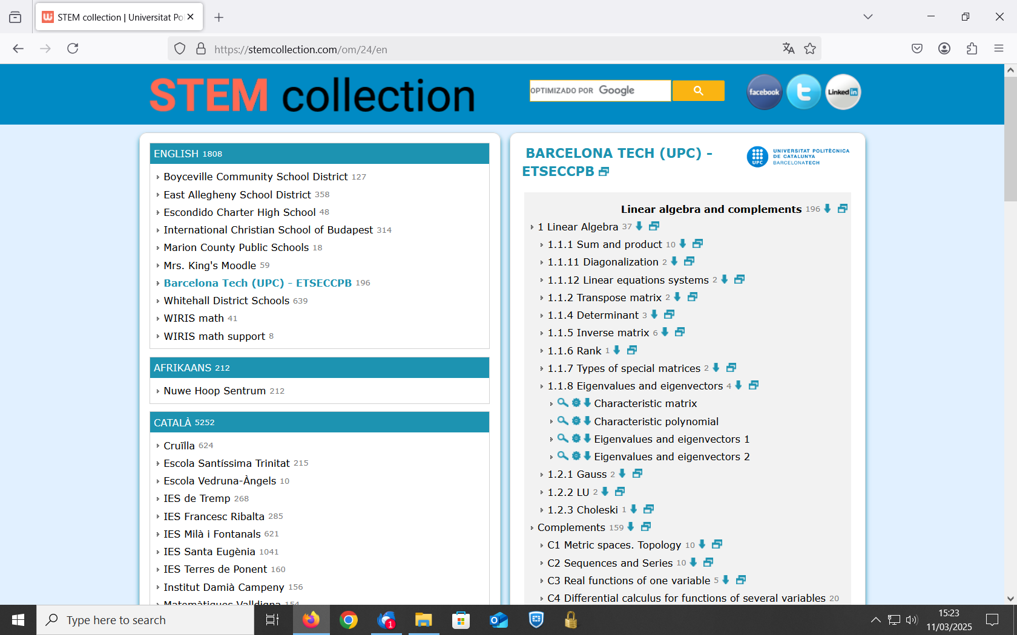

See that you can have the Algorithm of the question

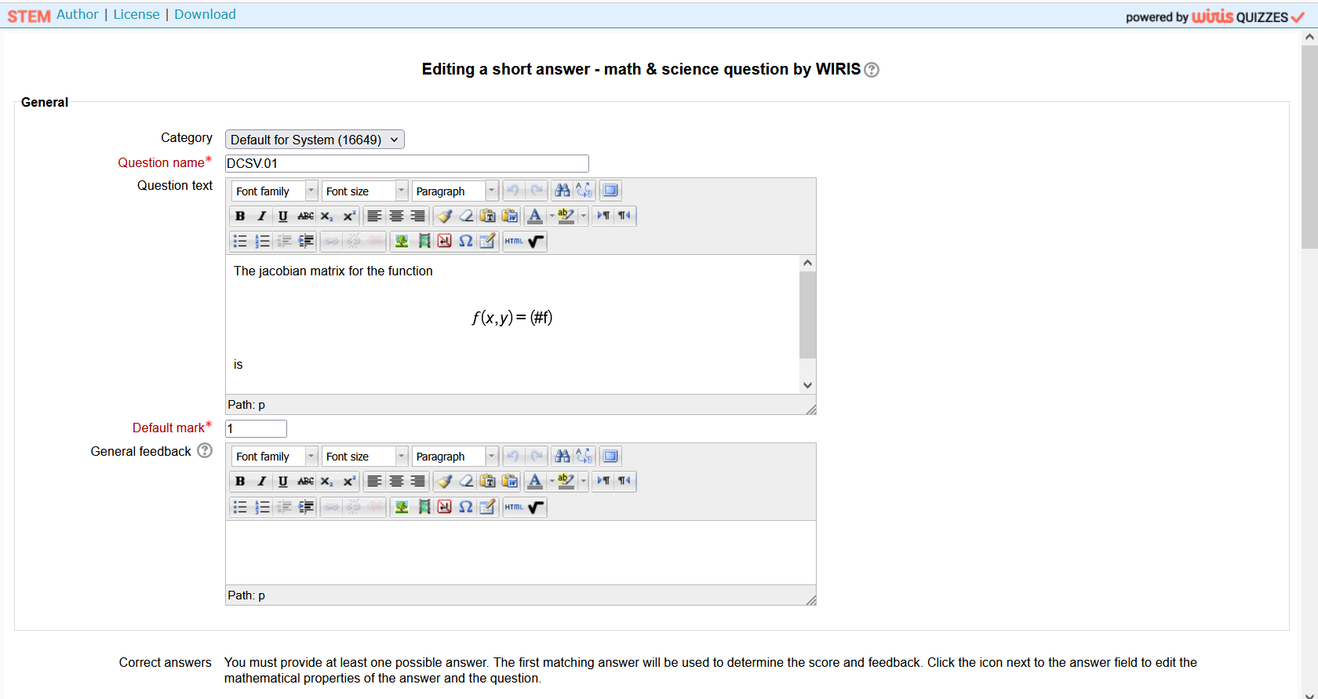
and also Download
