Interactive question of Inverse Matrix
https://stemcollection.com/r/11985/
Preview
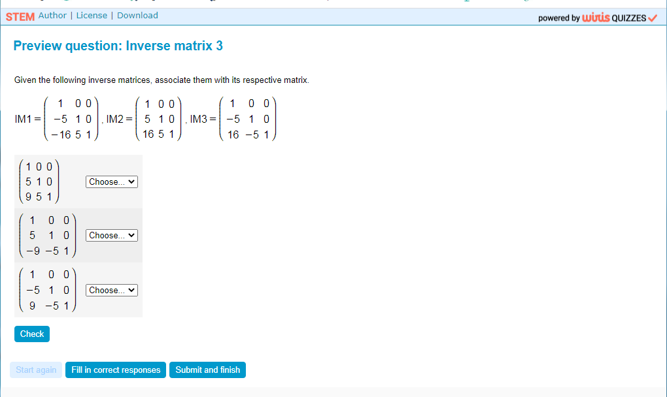
This question is part of the questions at STEM collection | WIRIS math
https://stemcollection.com/om/24/en

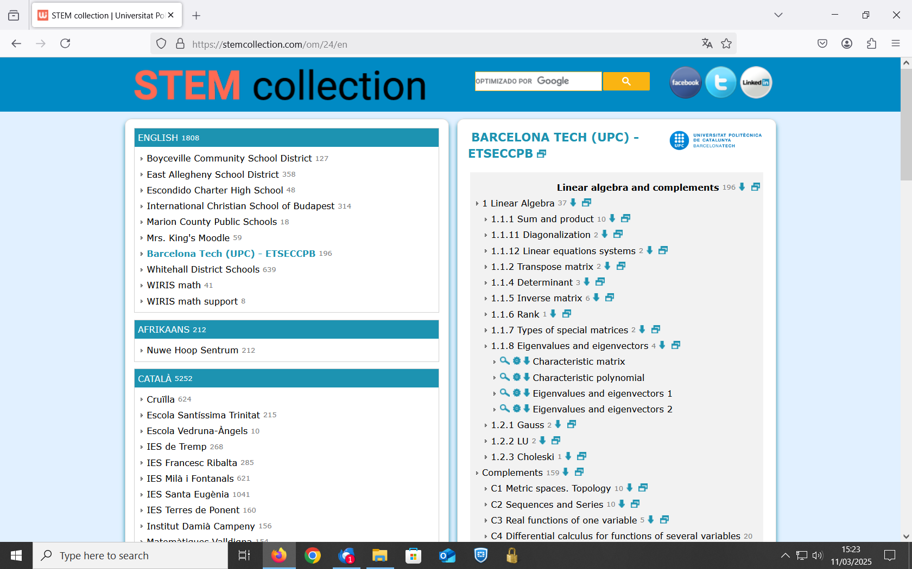

See that you can have the Algorithm of the question and also Download

