Interactive question of Eigenvalues and Eigenvectors
https://stemcollection.com/r/11994

Preview

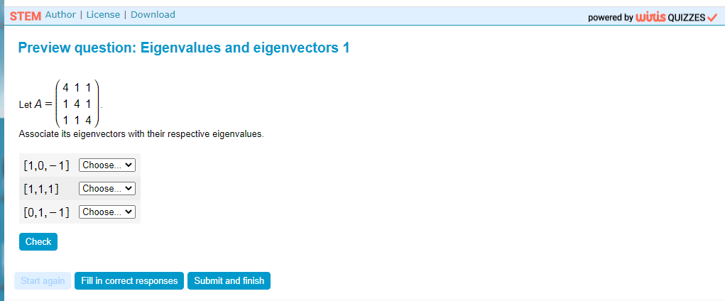

This question is part of the questions at STEM collection | WIRIS math

https://stemcollection.com/om/24/en

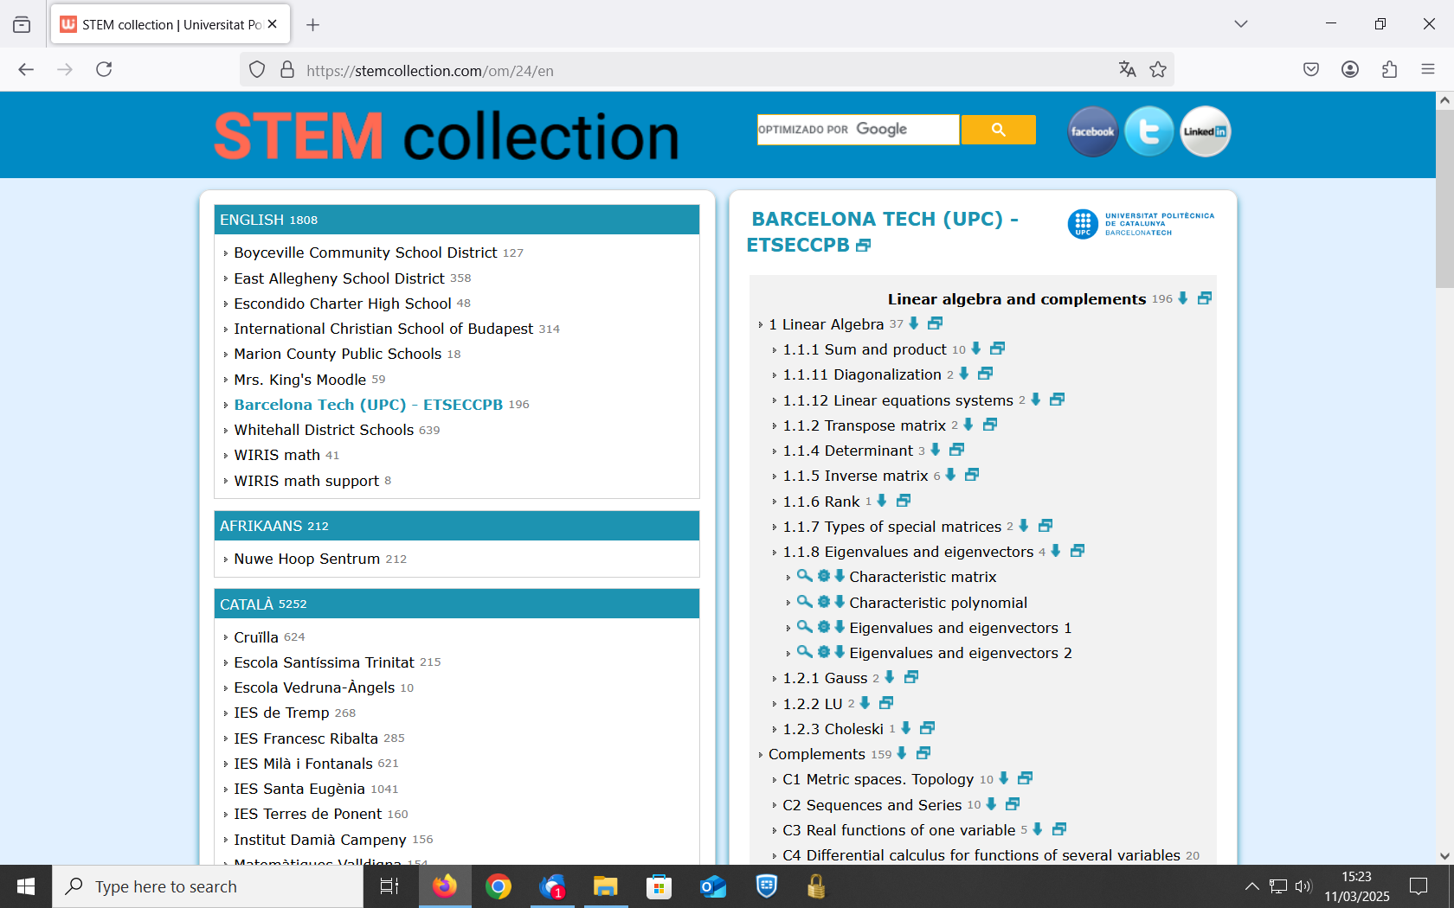
See that you can have the Algorithm of the question and also Download it

