Interactive question of basic concepts of Topology
https://stemcollection.com/r/12005

Preview
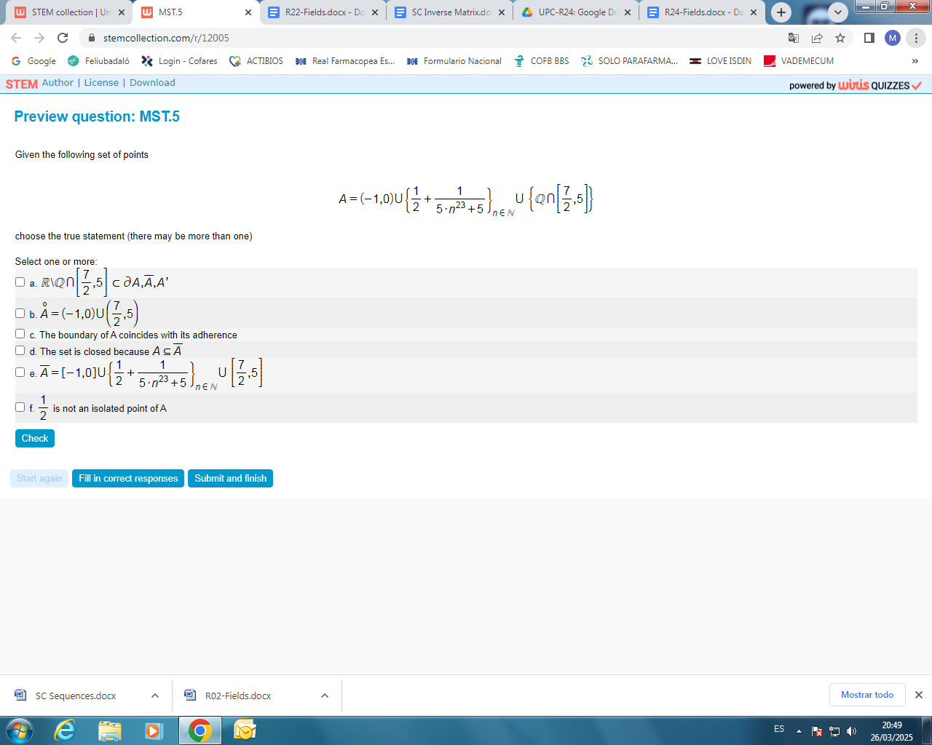

This question is part of the questions at STEM collection | WIRIS math

https://stemcollection.com/om/24/en

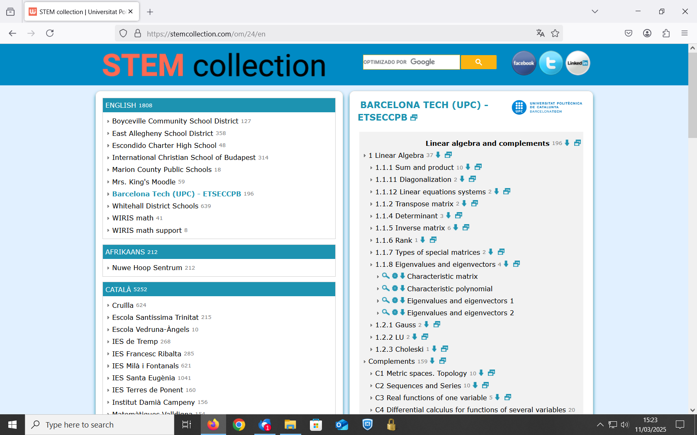

See that you can have the Algorithm of the question and also Download

