**Mosaics: Do it yourself!**

Surely you've found yourself staring at the tiles in a kitchen, or noticed the paving tiles on a street. Maybe you've even felt like creating your own designs. Here, you'll learn some basic techniques to get started, using GeoGebra

**PART 1: Periodic mosaics of type P1**

The simplest mosaics are created using parallelogram-shaped tiles: just translate ***the basic cell*** (the tile) in the two directions defined by its sides. These are called **mosaics of type P1**.

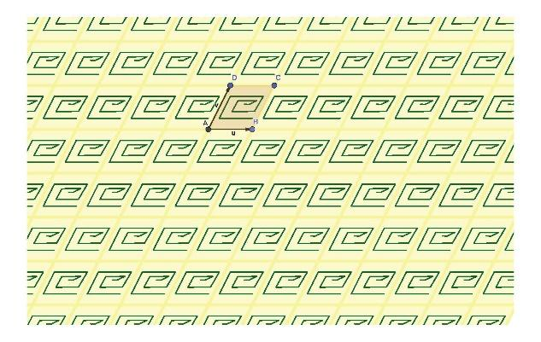

1. Create a parallelogram with vertices ***A, B, C*** and ***D***, and define the translation vectors as ***u = AB***and ***v = AD***.

To make GeoGebra apply a translation to any object, you can use the command:

***Translate(Object, Vector)***

where ***Object*** is the figure you want to move, and ***Vector*** is the direction of translation.

To perform multiple translations, you can combine this with the ***Sequence***:

***Sequence(Translate(Object, n*Vector), n, -r, r, k)***

Here, the values of ***r*** and ***k*** will determine how many and which translations are performed.

1. Cover the whole (visible) plane by translating the parallelogram in the direction of ***u*** and then ***v***. For instance::

***list1 = Sequence(Translate(Object, n*u), n, -r, r, k)***

***list2 = Sequence(Translate(list1, n*v), n, -r, r, k)***

You can also do both directions simultaneously:

***Sequence(Translate(Sequence(Translate(Object, n*Vector), n, -r, r, k), m*Vector), m, -r, r, k)***

1. Draw a motif (for instance, a polygonal line) inside the parallelogram. Then, using translations in ***u*** and ***v***, replicate it across all the tiles.

**PART 2: Periodic mosaics of type PM**

To obtain more complex mosaics, we can design the ***motif*** (the inner drawing of the basic cell) with some symmetry. For instance, divide the basic cell into two halves, draw in one half, and then reflect it in the other half. These mosaics are called **mosaics of type PM**.

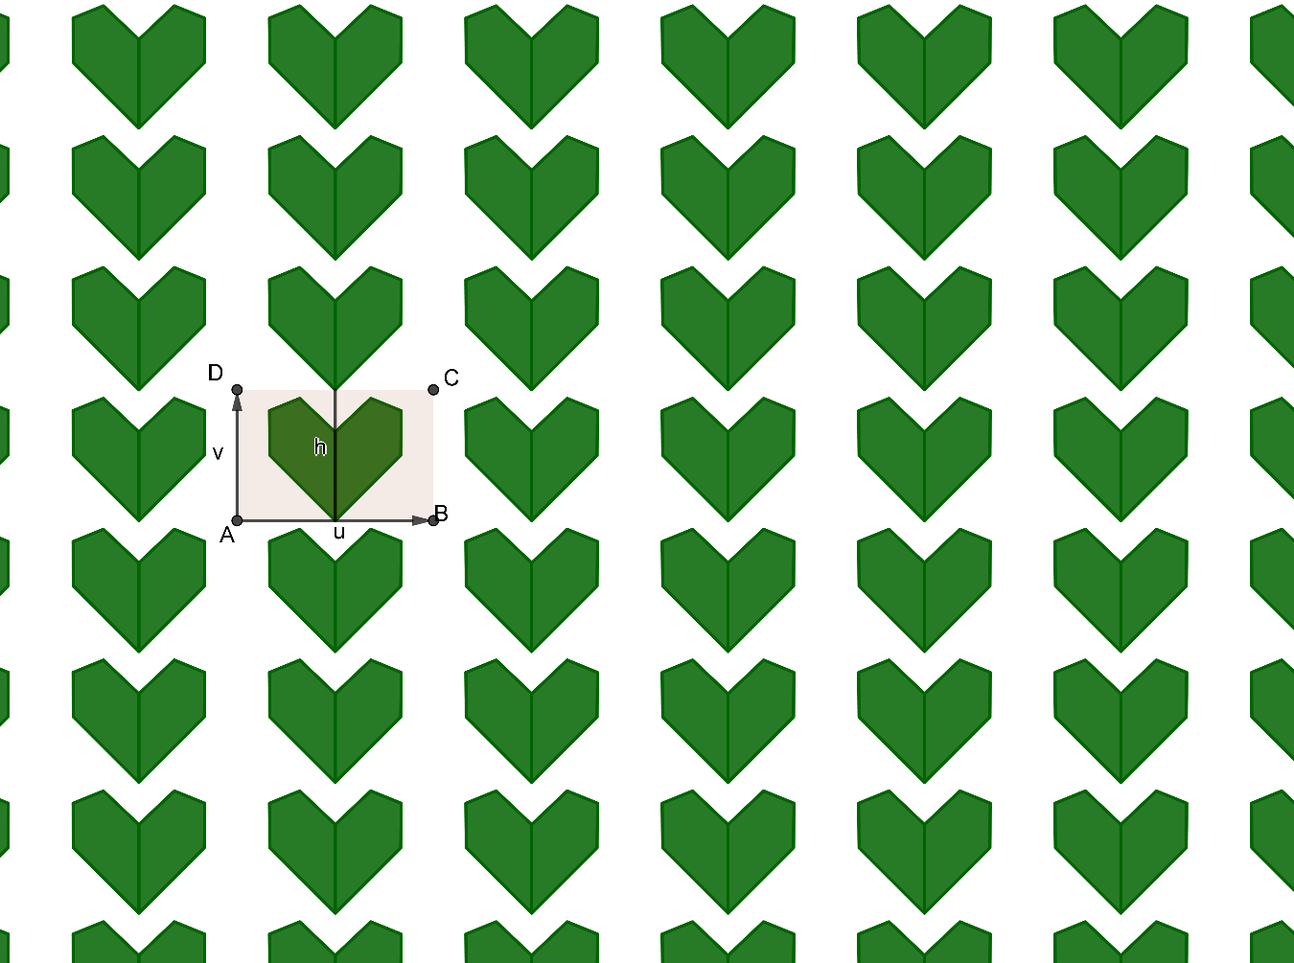

1. Create a rectangle with vertices ***A, B, C***, and ***D***, and vectors ***u = AB*** and ***v = AD***.
2. Find a segment ***h*** that divides the rectangle into equal parts. Draw a motif in one half, then reflect it across segment ***h*** using

***Reflect(Object, Line)***

6. Create a list of objects that includes the original motif and its reflection:

***List= {object1,object2}.***

7. Cover the entire plane by translating the list in the directions of ***u*** and ***v***.

**PART 3: Periodic mosaics of type P4**

Another common mosaic technique is to design the inner motif using rotations of a *minimal motif*.

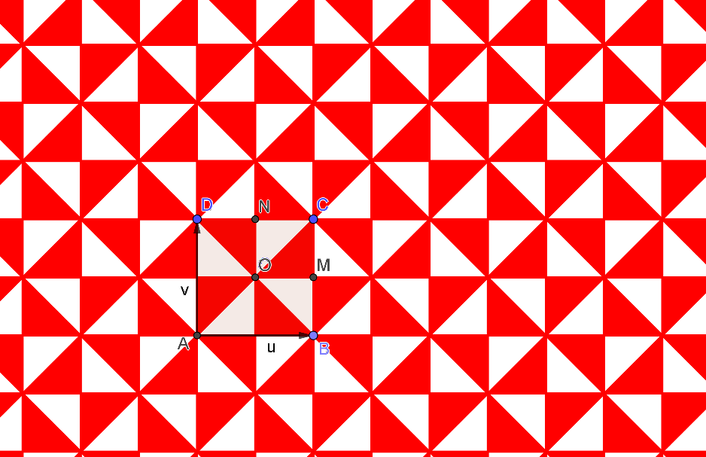

1. Create a square with vertices ***A, B, C***, and ***D***, and vectors ***u = AB*** and ***v = AD***.
2. Find the center of the square ***O***, and the midpoints of sides ***CB*** (point ***M***) and ***CD*** (point ***N***).
3. Inside the quadrilateral **{*OMCN*}**, draw a motif.
4. Perform successive rotations of angle $\frac{π}{2}$ around point ***O*** of the motif, until it completes a full cycle and store them in a list:

***List = Sequence(Rotate(Object, n*Angle, Center), n, 0, 3)***

1. Cover the entire plane by translating the list in the directions of ***u*** and ***v***.

**PART 4: Regular mosaic with hexagons**

The basic cells of a mosaic don’t necessarily have to be parallelograms. You can use other shapes like regular polygons. A well-known example is the floor of Passeig de Gràcia in Barcelona, made from hexagonal tiles:

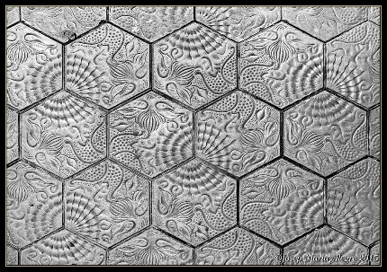

Now you’ll create a mosaic with hexagonal tiles in two colors:



1. Create a regular hexagon ***h1*** in green using two points ***A*** and ***B***:

***Polygon(A,B,6)***

1. Create another hexagon ***h2*** by rotating ***h1*** by an angle of 2π/3 around the point ***C*** marked in the previous figure. Color it red.
2. Define translation vectors ***v = FC*** and ***u = AE*** (see figure).
3. Create a row of green hexagons by translating ***h1*** in the direction of ***v*** so that it shares an edge with ***h2***. Once the row is complete, translate it in the direction of ***u*** to fill the pattern with green hexagons.
4. Create a row of red hexagons by translating ***h2*** along ***v***, ensuring they do not overlap with the green ones. Then translate this row with vector ***u*** to complete the red hexagon layer.

**PART 5: How to stamp a shape within a mosaic**

When you draw a closed shape in GeoGebra, you can fill its interior using one of the textures included in the program. o do this, open the polygon’s “*Properties*” and, under the “*Style*” tab, choose the texture from the “*Shading*” menu.

1. Draw a quadrilateral and fill it with one of GeoGebra’s textures.

Among the available shading options, you can also choose "*Image*", which allows you to use any image file to fill the shape.

1. Fill the previous quadrilateral with any image from your computer.

Thanks to this option, we can use previously created mosaics to stamp any closed figure. You just need to export the mosaic as an image file:

1. Open one of the previously created mosaics. Make sure it covers the entire GeoGebra Graphics View. *Go to File* > *Export* > *Export Graphics View as Picture*.

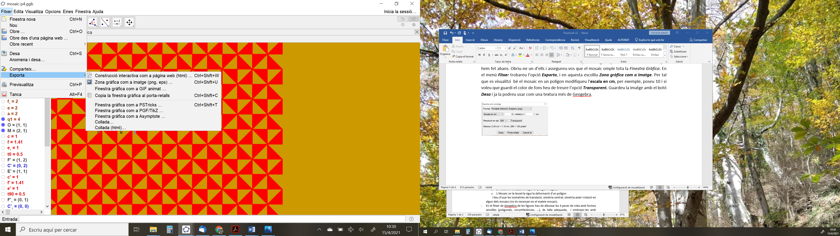

In the *Options* window that appears:

* Change the scale (e.g., 5 units = 1 cm) so the mosaic looks clearer.
* If you want to keep the background color, uncheck the Transparent box.

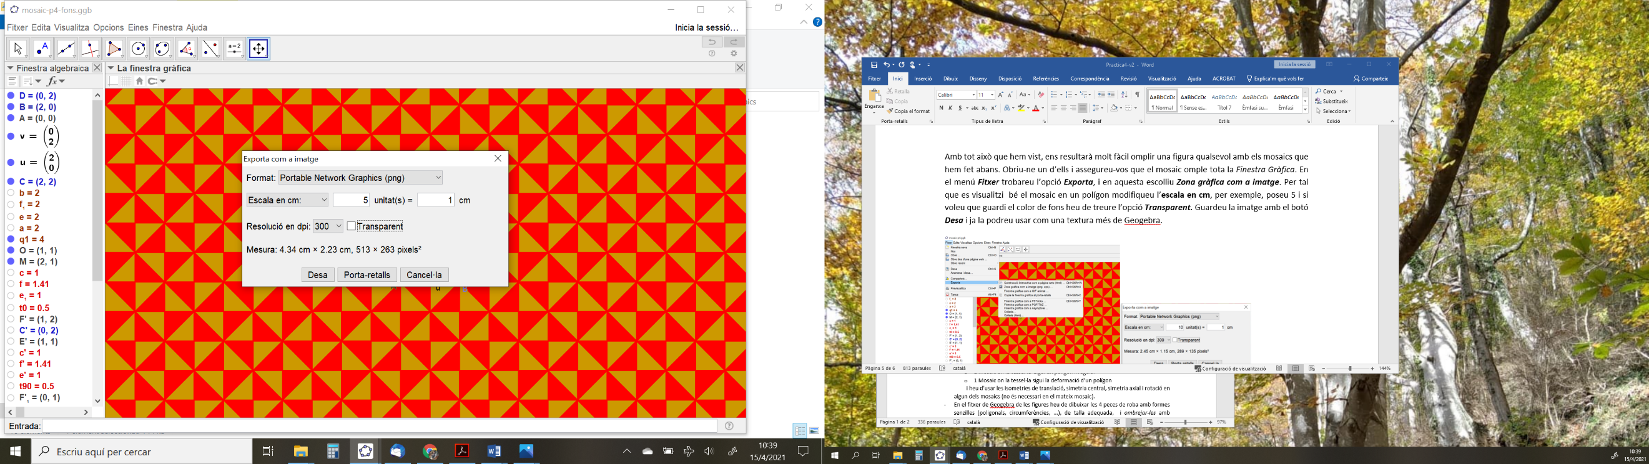

Save the image using the *Save* button. Now you can use it as a texture in GeoGebra.

1. Fill the quadrilateral with the image you just exported.